**Student Name :- Yash Gupta UID:-20BCS5009**

**Course :- Computer Science Engineering Section – 709-A**

**Subject – Software Engineering Subject Code – 20CPS-255**

**Experiment 1.2**

# ---

### *Consider software for academic activities of a university. The project will cover activities like managing of students as well as faculty. Design a SRS document for the project.*

# ---

## Introduction

## Purpose :

This section is written to provide general information about our product “COLLAGE-UNIVERSITY Management System”.

The main objective of our product is to maintain information of students, employees and other activities simultaneously like attendance, student marks, fee payment and etc.

The information is stored for decision making process within an organization.

This is a desktop application.

### Intended Audience :

This document is to be read by the development team, the project managers, marketing staff, testers, and documentation writers. The software engineer/Developer and project managers need to become intimately familiar with the SRS. Others involved need to review the document.

Testers need an understanding of the system features to develop meaningful test cases and give useful feedback to the developers.

The developers need to know the requirements of the software product they need to build.

This document is for general discussions on the implementation decisions regarding the College Management System. The user of the product should have the concepts of RDMS, SQL, interfaces, and classes.

### Project Scope :

As Colleges are growing day by day in numbers, size and also increasing the complexity of storing information of students and related to the college system, they face many issues such as attendance and fee of students , etc.

This project is based on the educational institute system where this application gives maximum services in a single software product that is used by teacher and system administration. This project is based on a desktop application that is sharing information on different departments in a college.

OVERALL DESCRIPTION

Product Perspective :

The main modules which are focused on this project:

Student management

Employee management

Student Fee management

Employee salary payment

User registration

Internal Marks of students

Attendance of students

Reports of all modules

## Product Features :

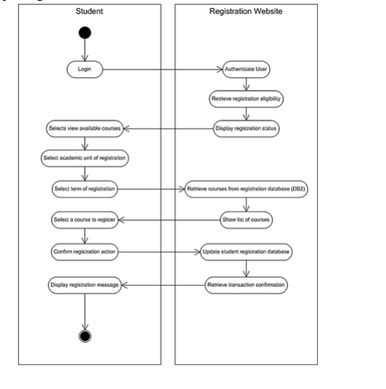

## Operating Environment :

The Collage Management System is expected to be deployed in a real environment to manage the Data Base Management System inside the college. The centralized database is used to store the information. The user only within the college can use this management system. Users outside form the college cannot access the management system. This application is developed for windows operating system that can be run on Windows XP and higher.

The database is used in different departments within a branch of the college. The database used to store the information is the centralized database. The software we have developed will be installed on different computer systems within a college and software will be connected to a centralized database through LAN within a college and then the user can interact with the system and can store the data and other users can get access the stored through a centralized database.

Design And Implementation Constraints :

During the implementation of the product, different challenges are faced. Choosing the interface for the management system was the main issue. Connecting the database with the application was a major problem.

For connecting the database we had to create our account in ORACLE and then we had to download the driver. The connection of the database that is created in ORACLE with C# is not very simple as like SQL. So the installation of ORACLE driver is necessary to create a connection between ORACLE and C#. But after installing the required driver it creates a problem in installing and connecting with a server in the oracle server, so we decided to leave the oracle and then we choose the SQL server to create the database.

Assumption Dependencies :

The login Id and password must be created by system administrator and communicated to the concerned user confidentially to avoid unauthorized access to the system.

It is assumed that a student registering for the subsequent semester has been promoted to that semester by the university as per rules and has paid desired university fee.

Registration process will be open only for specific duration.

**SYSTEM FEATURES**

Database – Storage :

Proposed Database is intended to store, retrieve, update, and manipulate information related to university which include

Profile of both users

Staff information

Student details

My account

Online payment

View attendance/marks/uploading of marks and assignments

**Stimulate/Response Sequences**

Responses for Administrator:

The administrator can Login and Logout. When the Administrator Logs into the University management system. The system will check for validity of login .If the Login and password are valid, the response to this action is the administrator will be able to modify, view, add, deleting and all other functions that can be performed on the database.

Functional Requirements :

This section gives the list of Functional and non functional requirements which are applicable to the University Management System.

**Hardware Interface**

Window’s XP or higher version.

Mozilla Firefox & Opera 7.0 or higher version.

**Software Interface**

**Database:** SQL Server.

**Application:** ASP (Active Server Pages)

**NON FUNCTIONAL REQUIREMENTS**

Safety Requirements :

The database may get crashed at any certain time due to virus or operating system failure. Therefore, it is required to take the database backup.

Security Requirement :

We are going to develop a secured database for the university .There are different categories of users namely teaching Administrator, Staff members and students etc. Depending upon the category of user the access rights are decided. It means if the user is an administrator then he can be able to modify the data, delete, append etc. All other users other than University Staff only have the rights to retrieve the information about database.

Soft Quality Attributes :

The Quality of the database is maintained in such a way so that it can be very user friendly to all the users of the database.

**Hardware Constraints**

The system requires a database in order to store persistent data. The database should have backup capabilities.

**Software Constraints**

The development of the system will be constrained by the availability of required software such as web servers, database and development tools.

The availability of these tools will be governed by the Lovely Professional University

ER DIAGARAM :

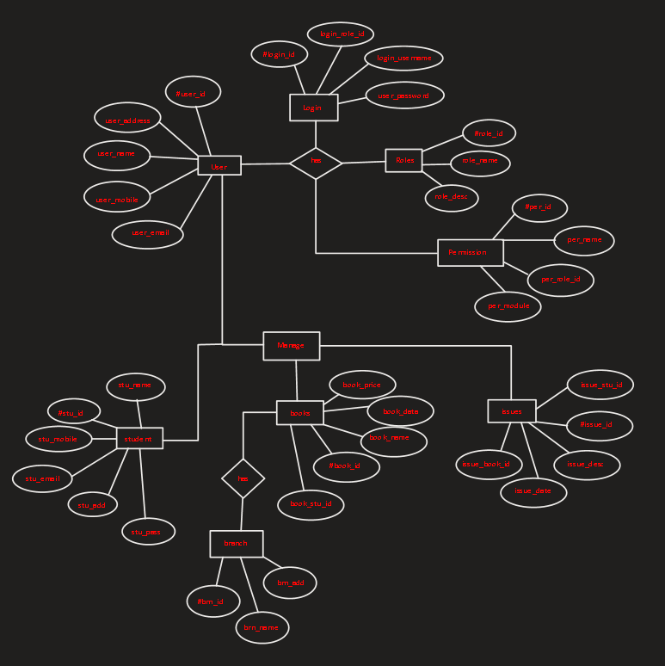

**DATAFLOW DIGARAM:**

ZERO LEVEL:

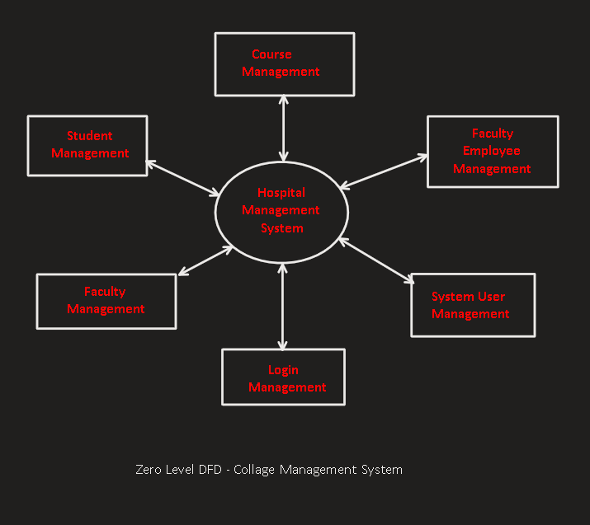

FIRST LEVEL:

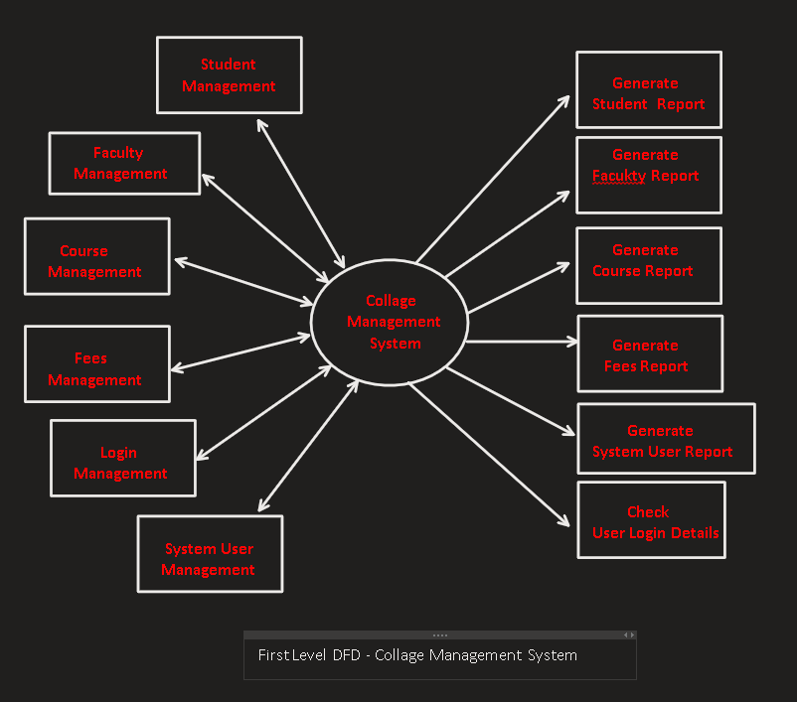

SECOND LEVEL:

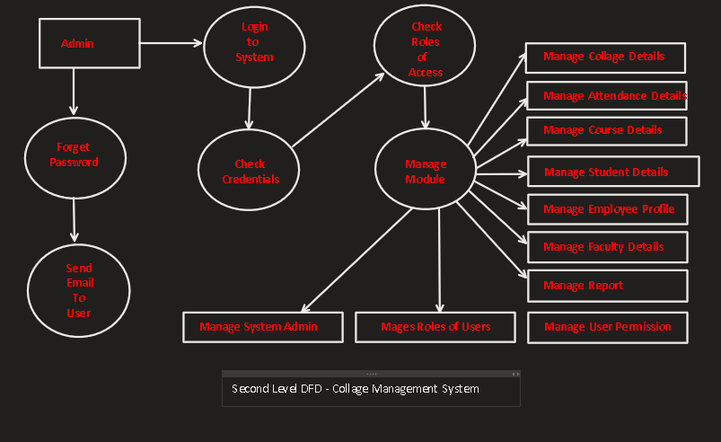

### Suppose your organization is planning to develop a travel application. Design a software requirement system for the given project.

**Introduction**

**Purpose:**

The purpose of this document is to describe the external requirements for an automated book-keeping system that keep track of various operations of a travel agency. It also describes the interfaces for the system.

**Scope :**

This document describes the requirements of the above-mentioned system. It is meant to be used by the developers and will be the basis for validating the final delivered system. Any changes made to the requirements in the future will be made with the permission of the client. The developer is responsible for asking for clarifications, where necessary.

**Definitions, Acronyms, Abbreviations:**

DFD – Data Flow Diagram

IEEE – Institute of Electrical and Electronics Engineers

**Intended Audience:**

This document will be used for design purposes by the developers and the design team. It will be the basis for validating the final delivered system.

**Functional Requirements**

**Register Customers**

**Collect Detail about Customer**

Input:

• Customer name, customer address, phone number.

Output:

• Request for deposit money (Rs. 5000).

• Updating entered data in customer database as temporary.

Description:

• Only for valid information Request is generated.

• New set of information given must not match completely with an existing entry in customer database.

**Gather Deposit Money**

Input:

• Confirmation of receiving deposit money,

• Previously entered customer data stored temporarily in customer database

Output:

• User name and password for the corresponding customer.

• Converting of temporary customer data to permanent.

Description:

• The employees of the organization permanently store the relevant data on confirmation of receiving deposit money.

**Process Online Request**

**External interface Requirements**

**User Interfaces**

This software needs the following user interfaces:

1. Registration Window:

User: The customer

Properties:

• This window is used for entry of customer details and registering a new customer for the online booking system.

• This window has various text fields to take the information name, address, phone number.

• There will be a register button upon pressing which deposit money is asked for.

1. Log in Window:

User: The customer, the employees of the organization using the software, the manager

Properties:

• This window has two fields for username and password, two buttons to log in and register.

• For correct user name and password it opens an appropriate window.

• It has register button to let new customer register by redirecting to registration window.

1. Customer Homepage:

User: Registered customer

1. Employee Homepage:

User: The employees of the organisation using the software when logged in

1. Manager Homepage :

User: The managers of the organisation using the software

**Software Interfaces**

The software runs under Linux or Windows operating system. This software uses two different databases for cars and customers. Internet using facility is must.

**Hardware Interfaces**

The system will run on a computer with at least 256 MB RAM and with internet connection. The machine is connected to a printer for printing bills etc.

**Communication Interfaces**

The software must be web browser enabled and HTTP protocol is used to transfer data.

**Other Non-functional Requirements**

**Performance**

In every case the response time will be less than 1 second except for the cases where internet connection is used.

**Security**

This software offers password protection so that only regular customers can book cars, only authorized personnel can edit data corresponding t0 booking, billing and car information.

**Data flow Diagram**

